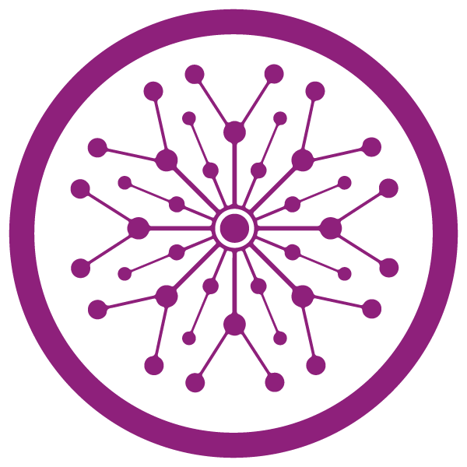

**Superior University Lahore**

***Lab Task # 6***

**Name:** Muhammad Abdullah Kashif

**Roll No**: SU92-BSAIM-F23-070

**Instructor**: Sir Rasikh Ali

# Course: Programming for Artificial Intelligence (Lab)

**Face Profiling Using OpenCV and MediaPipe**

**Step-by-Step Explaination:**

**1. Import Required Libraries**

import cv2

import mediapipe as mp

import math

* cv2: Used for webcam access and drawing.
* mediapipe: Used to detect face landmarks.
* math: Used to compute distances using the Euclidean formula.

**2. Initialize MediaPipe Modules**

mp_face_mesh = mp.solutions.face_mesh

mp_drawing = mp.solutions.drawing_utils

* mp_face_mesh: Loads the face mesh model.
* mp_drawing: Helps draw landmarks if needed.

**📷 3. Open the Webcam**

cap = cv2.VideoCapture(0)

* Captures video from the default webcam (index 0).

**4. Configure the Face Mesh Detector**

with mp_face_mesh.FaceMesh(

    static_image_mode=False,

    max_num_faces=1,

    refine_landmarks=True,

    min_detection_confidence=0.5,

    min_tracking_confidence=0.5) as face_mesh:

* static_image_mode=False: It processes video continuously.
* max_num_faces=1: Only one face will be detected.
* refine_landmarks=True: Enables high-accuracy landmark detection.
* min_detection_confidence=0.5: Confidence threshold for detection.
* min_tracking_confidence=0.5: Threshold for tracking landmarks.

**5. Capture Video Frame by Frame**

    while cap.isOpened():

        success, image = cap.read()

        if not success:

            break

* Continuously reads frames from the webcam.
* success: Indicates if the frame was successfully captured.

**6. Flip and Convert the Frame to RGB**

        image = cv2.flip(image, 1)

        rgb_image = cv2.cvtColor(image, cv2.COLOR_BGR2RGB)

        results = face_mesh.process(rgb_image)

* Flips the frame horizontally (mirror image).
* Converts BGR to RGB (MediaPipe uses RGB format).

**7. Detect Face Landmarks**

        image = cv2.flip(image, 1)

        rgb_image = cv2.cvtColor(image, cv2.COLOR_BGR2RGB)

        results = face_mesh.process(rgb_image)

* Processes the image and detects facial landmarks.

**8. Extract Facial Landmark Coordinates**

        if results.multi_face_landmarks:

            for face_landmarks in results.multi_face_landmarks:

                ih, iw, _ = image.shape

                def get_point(index):

                    landmark = face_landmarks.landmark[index]

                    return int(landmark.x * iw), int(landmark.y * ih)

This helper function:

* Converts normalized landmark positions (0 to 1) into image pixel values.

**9. Select Important Facial Points**

                left_eye = get_point(33)

                right_eye = get_point(263)

                nose_top = get_point(1)

                nose_bottom = get_point(2)

                left_lip = get_point(61)

                right_lip = get_point(291)

                left_face = get_point(234)

                right_face = get_point(454)

                chin = get_point(152)

                forehead = get_point(10)

* Points represent important landmarks needed for face profiling.

**10. Draw These Points on the Face**

                for point in important_points:

                    cv2.circle(image, point, 3, (0, 255, 0), -1)

* Draws green dots on each important facial point.

**11. Calculate Distances Between Points**

                eye_distance = math.hypot(right_eye[0] - left_eye[0], right_eye[1] - left_eye[1])

                nose_length = math.hypot(nose_bottom[0] - nose_top[0], nose_bottom[1] - nose_top[1])

                lip_width = math.hypot(right_lip[0] - left_lip[0], right_lip[1] - left_lip[1])

                face_width = math.hypot(right_face[0] - left_face[0], right_face[1] - left_face[1])

                face_height = math.hypot(chin[0] - forehead[0], chin[1] - forehead[1])

Uses the Euclidean distance formula to compute:

* Eye distance
* Nose length
* Lip width
* Face width and height

**12. Display Text Results on Screen**

                cv2.putText(image, f"Eye Distance: {int(eye_distance)}px", (30, 30),

                            cv2.FONT_HERSHEY_SIMPLEX, 0.7, (0,255,0), 2)

                cv2.putText(image, f"Nose Length: {int(nose_length)}px", (30, 60),

                            cv2.FONT_HERSHEY_SIMPLEX, 0.7, (0,255,0), 2)

                cv2.putText(image, f"Lip Width: {int(lip_width)}px", (30, 90),

                            cv2.FONT_HERSHEY_SIMPLEX, 0.7, (0,255,0), 2)

                cv2.putText(image, f"Face Width: {int(face_width)}px", (30, 120),

                            cv2.FONT_HERSHEY_SIMPLEX, 0.7, (0,255,0), 2)

                cv2.putText(image, f"Face Height: {int(face_height)}px", (30, 150),

                            cv2.FONT_HERSHEY_SIMPLEX, 0.7, (0,255,0), 2)

...

* Writes the measurements on the screen in real-time.

**13. Show the Frame with Overlays**

cv2.imshow('Full Face Profiling', image)

* Displays the frame in a window named **"Full Face Profiling"**.

**14. Exit on ESC Key Press**

if cv2.waitKey(5) & 0xFF == 27:

            break

* Exits the loop if the ESC key is pressed.

**15. Cleanup**

cap.release()

cv2.destroyAllWindows()

* Releases the camera and closes all OpenCV windows.

**Output Summary:**

